Lattice IsoTruss Structure for Wind Turbine Towers

Contact:

Mrs. Marianne Clayton

marianne@isotruss.com

801.836.7034

# Project Description

In the wind industry, composites obviously play a big role in innovation of blades to be larger, lighter, and more efficient. This project proposes another area of the wind industry that could be more efficient with the use of composites – the support tower for turbines. Typical wind turbine towers are tubular steel, tubular concrete, steel lattice or steel guyed structures[1]. Steel and concrete towers are heavy, use carbon-intensive materials, and are subject to corrosion especially in humid areas or offshore turbines. Replacing steel or concrete wind turbine towers with composite lattice IsoTruss towers will reduce material, make installation easier, and increase the lifetime. The IsoTruss geometry optimizes the placement of fibers in the composite to align with the loading which allows material savings of up to 12X compared to steel structures. The material savings result in a weight savings as well, with the structures being much more easily maneuverable and requiring less heavy machinery for installation and delivery. The corrosion resistance of composites also has significant impacts for product lifetime, especially in humid or coastal environments. One IsoTruss telecom tower customer stated that steel towers can corrode after 5 years in extreme environments where composite towers are rated to last more than 50.

This innovation addresses the global wind power market. The global market was valued at over $99 billion in 2021 with expected compounded annual growth rate (CAGR) of 6.5% from 2022 to 2030[2]. The heightened emphasis on wind technology is also evident in the recently announced goal to target 15 gigawatts of floating offshore wind capacity by 2035 in the US[3].

This project is meant to increase efficiency in wind energy technology. Transitioning from steel or concrete towers for wind turbines to composite structures has the possibility of reducing lifecycle costs both financially and environmentally. The combination of lighter weight and corrosion resistance in IsoTruss composite structures amounts to significant cost savings for customers. Composite IsoTruss towers in the telecom industry have been shown to reduce weight by up to 1/12, which both decreases delivery costs and makes maneuverability onsite easier with less heavy equipment during installation. Customers have estimated installation cost savings of 60% with IsoTruss towers compared to steel towers because of the lighter weight. Composite materials are also corrosion resistant even in the most extreme humid and salty environments, and IsoTruss towers are rated to extend usable life up to 5X in these conditions. Customers save both maintenance and upkeep costs as well as reduced replacement costs by switching from steel to composites. On the environmental side, IsoTruss towers both use less material and are replaced less frequently which combine for an estimated 70% reduction in CO2 emissions over the lifetime of an IsoTruss tower.

# Results

## Milestone 1: Project Management

All project milestones and tasks assigned to the IsoTruss team are complete (see Figure 1). Both cost share and IACMI funds were used in full during the course of the project.

 

Figure 1. Gantt chart showing project milestones. All milestones assigned to IsoTruss are completed; nacelle fabrication is ongoing.

## Milestone 2: Design of IsoTruss Structure for Wind Turbine Towers

Composites have the possibility of addressing three main challenges of current steel wind turbine towers:

1. Transportation: large components require special trucks and routes to get from the manufacturing facility to the deployment site.
2. Installation: large, heavy components require heavy-duty cranes and other equipment to install. Installation is expensive and time consuming.
3. Corrosion: steel requires special treatment and maintenance to protect against corrosion. This problem will only become more challenging as off-shore applications increase.

The ideal composite replacement of a steel wind turbine tower significantly reduces the cost/time of all three challenges above.

### Composite Monopole Designs

This project utilized the WISDEM software to generate a typical steel turbine tower. The NREL 5MW reference turbine was used for tower design which has the specifications in Table 1. The details for the steel tower created with the 5MW turbine are also shown in Table 1.

Table 1. Details of the NREL 5MW reference turbine used in this project.

| NREL 5 MW Reference Turbine | |
| --- | --- |
| *Turbine Specifications* | *Tower Specifications* |
| Turbine Class: I | Tower Height: 88 m |
| Turbulence Class: B | Tower Diameter: 6 m base; 4 m top |
| Drive Train: Geared | Wall Thickness: 0.03 m (max) |
| No. Blades: 3 | Mass: 256,000 kg |
| Hub Height: 90 m | Axial Load: 1.5 MN |
| Rotor Diameter: 126 m | Overturning Moment: 6.8 MN-m |

Composite tower solutions were designed to match stiffness and torsional rigidity of the steel solution with as little weight as possible. One solution evaluated a carbon fiber monopole – the same basic geometry as a steel solution. The diameter of the tower was calculated to match stiffness and torsional rigidity of the steel solution. An IsoTruss monopole solution was also created for comparison that also matched stiffness and torsional rigidity. Wall thickness for the two composite solutions was limited to a maximum of 1 inch because thick parts become difficult to consolidate in filament winding or infusion processes. Renderings of the steel, carbon fiber, and IsoTruss monopole towers are shown in Figure 2. Table 2 shows the dimensions of each tower. The composite solutions have significantly larger diameters than the steel solution because carbon fiber is not as stiff as steel (although the stiffness-to-weight ratio is higher for carbon fiber than for steel). The composite solutions are also much lighter than the steel solution at about half the weight.

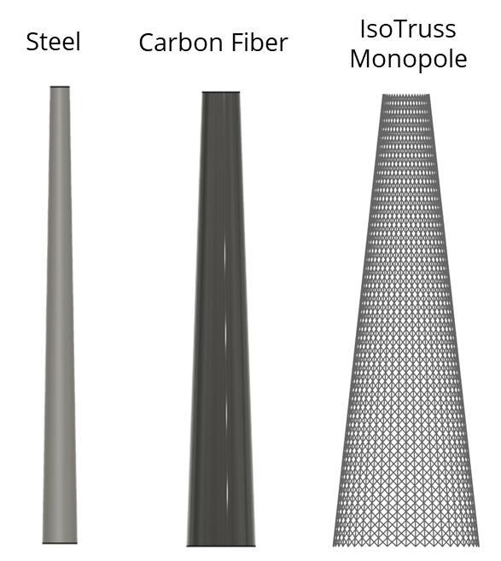

Figure 2. Renderings of monopole tower designs using steel, carbon fiber, and IsoTruss geometry, each tower with the same stiffness and torsional rigidity.

Table 2. Dimensions for the monopole tower designs.

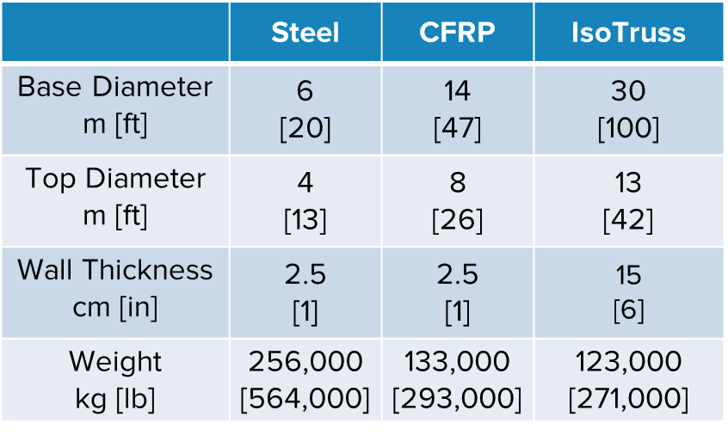

With respect to the three main challenges to solve with steel towers:

1. Transportation: any benefit from a lighter weight solution is negated by the larger diameters which would still require specialized equipment and routes for delivery.
2. Installation: the lighter weight of the composite solutions may require smaller installation equipment (such as cranes) for less time, but it is difficult to conclude because of the larger diameter.
3. Corrosion: carbon fiber would undoubtedly improve the corrosion performance of the tower compared to the steel solution.

### IsoTruss Modular Design

The monopole design effectively uses the carbon fiber as “black steel”, i.e. using the same geometry and only changing the material. Composites have unique properties, however, that make possible creative designs that would not work for a steel solution. The Modular IsoTruss design uses smaller IsoTruss sections as building blocks to create the larger structure. Where many small steel sections to be assembled onsite would be time and cost prohibitive for a steel solution, a lightweight composite solution is more feasible.

The Modular IsoTruss has 40-inch diameter, 20-foot long IsoTruss sections as the building blocks (Figure 3). A 40-inch diameter was used because it is the currently the largest diameter tower product offered by IsoTruss, although in future work the diameter could be optimized for cost savings and ease of installation. 20 feet in length is convenient because it fits in standard shipping containers, although this number could be optimized based on truck bed length and ease of installation.

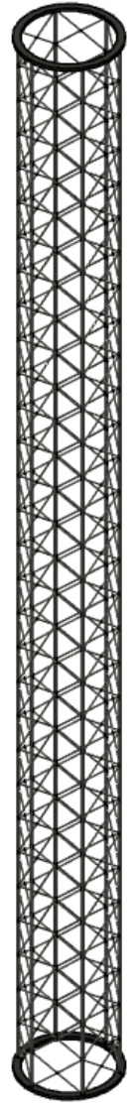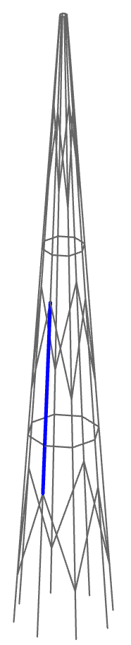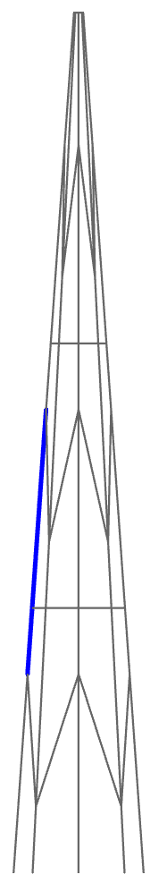

Figure 3. Rendering of the Modular IsoTruss design. Each member (line) is a 40-inch diameter, 20-foot long IsoTruss section.

The Modular IsoTruss design requires joints to connect each section. Joining composite sections is a challenge. In previous projects, IsoTruss has used fully composite joints in bike frames that are manufactured separately from the IsoTruss and then attached by bonding. Current IsoTruss towers have flanges on each section end with a bolted connection. Photos of both connection methods are shown in Figure 4. The design concept for this project used a bolted connection because the assembly will take place onsite.

Figure 4. Photographs of IsoTruss connections. Towers (left) use bolted connections, while bikes (right) use joints that are manufactured separately and then attached.

There are two types of connections in the Modular IsoTruss design: longitudinal-longitudinal connections and longitudinal-helical connections. Longitudinal members are vertical or axial members. Helical members are diagonal and horizontal members.

Longitudinal-Longitudinal: These connections can use the same design as current IsoTruss tower connections. The flange is wound as part of the continuous winding process used to create the IsoTruss. U-brackets straddle the longitudinal and provide points for bolted connections without putting holes in the composite. Renderings of longitudinal-longitudinal connections and of one U-bracket are shown in Figure 5.

Figure 5. Renderings of a longitudinal-longitudinal connection. This is similar to the design currently used for telecom towers.

Longitudinal-Helical: These connections have four IsoTruss sections meeting at the same point. A 4-sided IsoTruss joint piece was designed to be inserted between IsoTruss sections with flange connections for all four incoming IsoTruss sections similar to the longitudinal-longitudinal connections. Renderings are shown in Figure 6.

Figure 6. Renderings of a longitudinal-helical connection. A separate joint IsoTruss section is inserted to create the four-way connection.

The side rings to attach the diagonal or horizontal members would require different manufacturing than a typical IsoTruss (see Figure 7). Continuous winding of the ring with the rest of the joint would be ideal, but tooling would be complicated and potentially not feasible. The side ring could be bonded to the rest of the joint in a secondary process. Bonding requires a large surface area, so the design may need adjustments for a bonding process to be effective. The ring could also potentially be bolted to the longitudinal members in the joint, although this adds more metal and thus more weight and corrosion potential. IsoTruss joints is an intriguing research opportunity highlighted by this project, with significant potential to open new applications.

Figure 7. Detailed view of the joint section to connect four sections in the Modular IsoTruss design.

The Modular IsoTruss concept was also designed to match stiffness and torsional rigidity of the steel solution. The design used 40-inch diameter, 20-foot long sections with a maximum of 1-inch diameter for any member. The number of IsoTruss sections used, the placement of the sections, and the diameter of the base were optimized to reduce weight while meeting performance requirements. The dimensions of the Modular IsoTruss design compared to steel, carbon fiber monopole, and IsoTruss monopole designs is shown in Table 3.

Table 3. Dimensions for monopole designs contrasted with the Modular IsoTruss design.

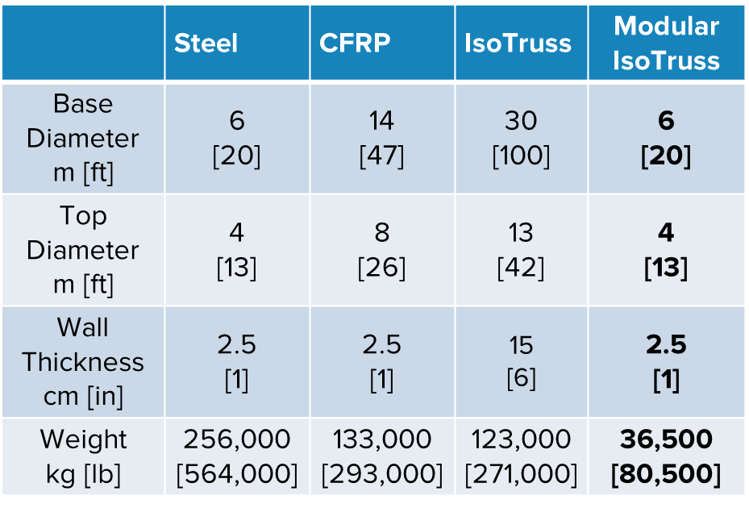

Table 4 shows the dimensions of each design as a factor of the steel design. The monopole designs have significantly lighter weight, but the tower dimensions are drastically larger than steel. The Modular IsoTruss, on the other hand, can match the steel design for base and top diameters while also reducing the weight by one-tenth.

Table 4. Dimensions for all design concepts shown as a factor of the steel dimensions. The Modular IsoTruss design significantly reduces weight compared to the steel design without adding a large footprint to the tower size.

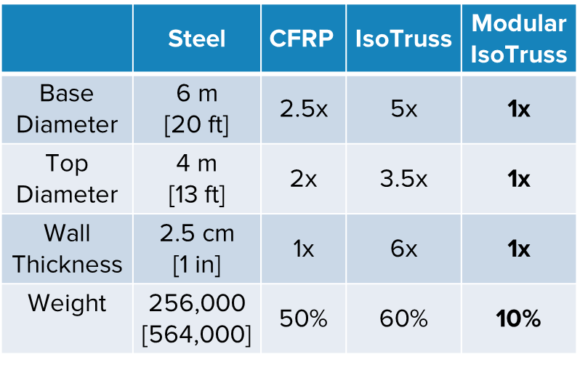

The Modular IsoTruss design addresses all three challenges of steel towers:

1. Transportation: the small IsoTruss sections are lightweight to ship. They can fit into shipping containers or truck beds, with space in the container being more of a constraint than weight. No special truck or route is required.
2. Installation: the lighter weight pieces can be installed much more easily with less time and expense. Individual sections can easily be moved by hand if needed. The current joint methods using bolted connections are time intensive – this solution could be improved in expense and time with further research and development.
3. Corrosion: as with the other carbon fiber solutions, corrosion is no longer a problem.

## Milestone 3: Fabrication of Demonstration Piece

The purpose of the fabrication piece was to highlight the benefits and potential of a technology on a small scale meant for trade shows, conferences, and other publicity events. The demonstration piece used an existing IsoTruss mandrel about 2-inches in diameter and 6 feet long.

The joints were 3D printed and designed for easy shipping, assembly, and disassembly (Figure 8). The 3D printed joints attach around the longitudinal IsoTruss with brackets to secure the joints. The diagonal (helical) IsoTruss sections slide over joint.

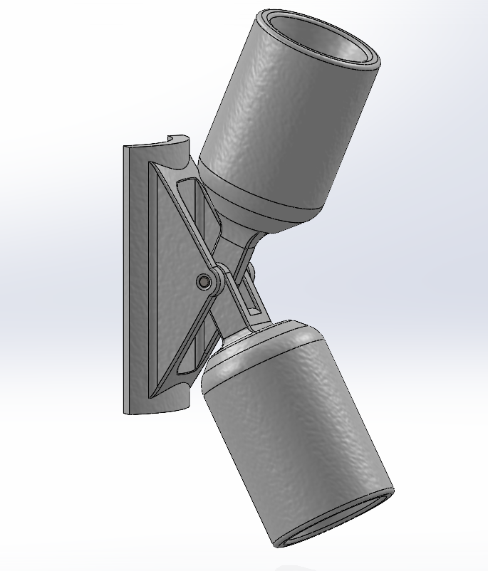

Diagonal IsoTruss Connection

Vertical IsoTruss Connection

Figure 8. Rendering of the joints created for the demonstration piece. This joint was designed for easy assembly and disassembly.

The final demonstration piece stands about 6 feet high and showcases IsoTruss technology and the potential for composite joints. The demonstration tower with assembly instructions were delivered to IACMI. One photograph is shown in Figure 9 with additional photographs included at the end of the report.

Figure 9. Photograph of the demonstration piece showing the potential for IsoTruss in large wind turbine towers.

## Milestone 4: Cost Analysis

The cost analysis was meant to compare as accurately as possible the costs of the IsoTruss modular solution to the steel solution. The tower portion of any turbine is about 20% of the total cost[4] and in 2022 turbines cost $900/kW and $1500/kW to install[5]. For the 50MW turbine used in Milestone 1 this means a tower cost of $8.75M and $15M in installation.

From previous experience introducing composite solutions into infrastructure markets, composites can compete with steel in adoption when capital costs are within 10-20% of steel costs. Even a superior product – with corrosion resistance, longer life, more resilience, etc. – will not capture customer interest at a significant premium because capital costs are so much more of a focus than total lifetime costs. Therefore, for a composite tower solution to be commercially feasible it is assumed that the price must be competitive with current steel solutions.

Composite material costs are higher than steel – drastically higher for carbon fiber – so a cost parity for a composite solution to a steel solution has to save costs in manufacturing and/or installation. It was difficult to extrapolate manufacturing and installation costs for composites structures on a much larger scale, so in an effort to be as accurate as possible, the material vs installation costs were compared for telecommunications towers where IsoTruss has previous data.

Figure 10 shows that IsoTruss towers have higher material costs than steel, but the higher cost is equalized by the lower installation cost. The composite tower has 20% higher material costs than the steel tower, but the installation costs are reduced by the lighter weight so that the overall cost is close to equal.

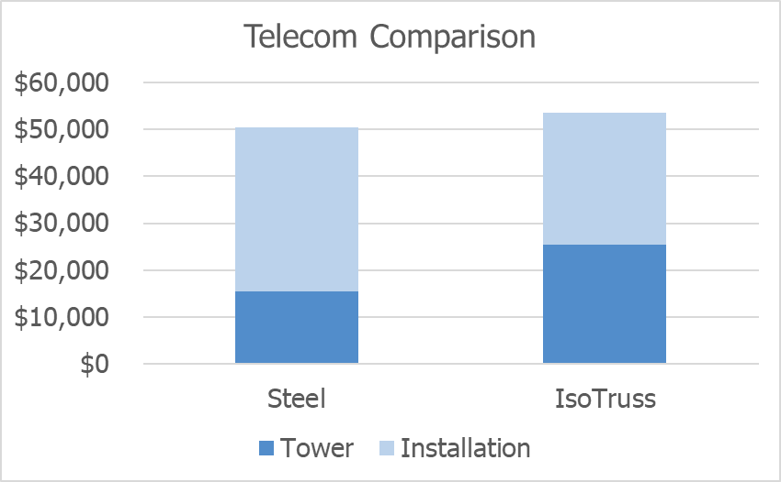

Figure 10. Comparison of tower versus installation costs for a telecom application. The IsoTruss Tower has higher material costs but lower installation costs, so the overall cost is close to equal.

The calculations here assume $20 per pound for carbon fiber because that is the current cost of prepreg used by IsoTruss. This cost is not realistic for the scale of a wind turbine tower, so the comparison in Figure 10 can be viewed as a worse-case scenario. Replacing carbon fiber with glass fiber, wet winding, and additional automation have been considered as ways to reduce material costs. If material costs can be reduced to $5 per pound or lower the cost advantage of the composite solution versus steel only becomes more obvious.

Figure 11 shows a comparison between two manufacturing methods – filament winding and braiding – for 40-inch diameter, 20-foot long IsoTruss sections (the dimensions used in the Modular IsoTruss design.) Material costs are identical for both manufacturing methods – each can utilize prepreg fiber or wet winding. Manufacturing costs relate to equipment operating expenses and labor. These costs are much lower for braiding because it is a continuous process with less touch labor. Braiding presumably only requires a break in manufacturing when a spool needs to be replaced. Filament winding, on the other hand, can only make one 20-foot section at a time in a batch process. Equipment costs are also an important factor. Filament winding has lower equipment costs, although a mandrel for filament winding is only usable for a specific set of dimensions. Braiding has higher initial equipment costs with a lot of the equipment custom built. The investment in braiding becomes worthwhile when thousands of parts are expected to be produced because the operating costs are so low. Braiding, when used with an external hook system rather than an internal mandrel, can also adjust part dimensions without requiring new tooling.

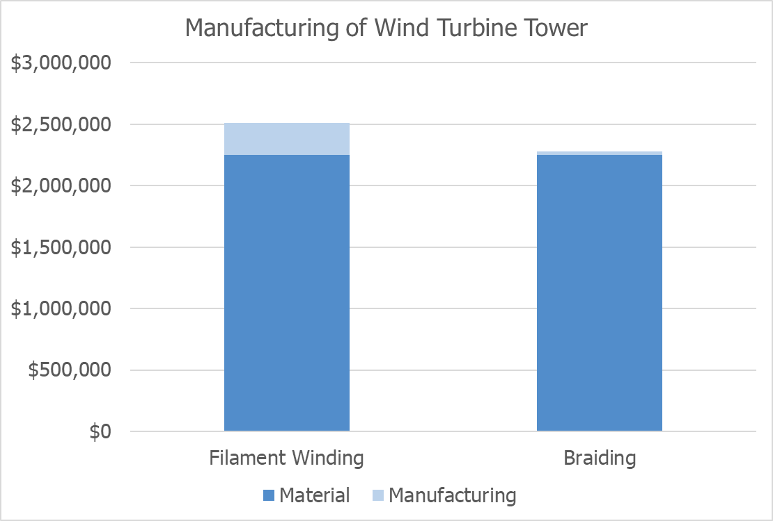

Figure 11. Comparison of manufacturing a wind turbine tower with filament winding versus braiding. Both methods have the same material costs but different manufacturing or operational costs. Braiding has more upfront costs for equipment and development, but operational costs are almost negligible.

# Conclusion

* Composites show promise in infrastructure applications such as wind turbine towers because of installation savings and corrosion resistance.
* Composite solutions can (and should be) unique to take advantage of their unique capabilities. For example, a modular IsoTruss solution is more advantageous than a monopole solution and feasible because of the IsoTruss sections are so lightweight.
* To be competitive, any composites solution should aim to be close to parity with current steel solutions. Although the material cost is higher, cost savings come in using less material and easier transportation and installation.

# Next Steps

There are three important research areas that need further development for an IsoTruss wind turbine tower to be successful: 1) material selection, 2) manufacturing methods, and 3) joints. Figure 12 shows a visual representation of these research areas with an estimated timeframe.

Figure 12. Material selection, manufacturing methods, and connections are three important research efforts for an IsoTruss wind turbine tower to be successful. This figure shows details about each category with an estimated timeframe.

## Material Selection

Material costs are a significant portion of composite products. Decreasing material costs – such as by decreasing material usage or altering manufacturing method – are especially important in infrastructure applications where competing products use commoditized materials.

IsoTruss has previously used carbon fiber because the higher modulus results in higher weight savings. The scale of the proposed wind turbine tower application, however, may make glass fiber the better material choice. Further evaluation of fiber cost versus material used will help make this decision. We anticipate this material selection research to be completed in the next 12 months with internal IsoTruss resources.

## Manufacturing Methods

Manufacturing of IsoTruss products must be at a speed and cost that competes with commoditized steel products. Lower cost alleviates some of the pressure on manufacturing costs, but product lead time is also a vital part of a commercially viable product. IsoTruss is currently working toward further automation of its proprietary manufacturing process which involves development work on tooling, machinery, consolidation, and assembly/disassembly. Manufacturing processes is an area that benefits from continuous improvement, but we anticipate significant development toward production readiness and additional automation in the next approximately two years.

## Composite Joints

The IsoTruss Modular design in this project showed an example of how versatile IsoTruss structures can be with appropriate joints. Similar conclusions have been made for smaller diameter IsoTruss structures, such as those used in IsoTruss bike frames. This project explored two different ideas for connections – one in the Milestone 1 and another in Milestone 3. Milestone 1, the design process, used joints that connected to flanges on IsoTruss structures with bolted connections. This design is feasible for something as large as the wind turbine tower, however, assembly labor would be intensive. The other concept during the prototype in Milestone 3 attached around the vertical IsoTruss pieces and slide inside the diagonal IsoTruss pieces. This concept shows that joints can be unique in order to take advantage of unique properties of composites and IsoTruss. Further research is needed to continue developing joints that perform well but minimize installation difficulty and cost.

Joining composites is a challenge and an area of research in many industries – aerospace, automotive, and wind to name a few. Cost is a huge driver for infrastructure applications (more so than aerospace, for example) which pushes current IsoTruss products to use bolted connections. It would be advantageous to have a fully composite solution so that the benefits extend not just to the structure but to the connections as well. Connections will be a longer-term research project – multiple projects could address solutions for various applications and industry needs. This is also an area where collaboration with other IACMI members could be beneficial.

# Additional Demonstration Piece Photos

1. https://www.windfarmbop.com/wind-turbine-tower/
2. https://www.grandviewresearch.com/industry-analysis/wind-power-industry
3. https://www.compositesworld.com/news/new-initiatives-launched-to-expand-us-offshore-wind-energy
4. http://xn--drmstrre-64ad.dk/wp-content/wind/miller/windpower%20web/en/tour/wtrb/tower.htm
5. https://www.energy.gov/sites/default/files/2022-08/land_based_wind_market_report_2202.pdf