Recycling/Circular Economy Working Group Session Summary
October 2020

Working Group General Guidelines

129 People Attended

Mission and Scope:
- Foster and accelerate the development and adoption of innovative recycling technologies for low-cost, energy efficient advanced composites recycling.

Meeting Minutes
- Soydan Ozcan opened the meeting with a presentation on the IACMI composite recycling group, welcomed individuals to the meeting.
- Alex Fitzsimmons, Deputy Assistant Secretary for Energy Efficiency, gave a short talk about the ongoing initiatives and investments within the U.S. Department of Energy in collaboration with IACMI and Oak Ridge National Lab. He discussed IACMI’s role in the recycling initiatives as well as the opening ceremony of the Composites Recycling Hub at the Manufacturing Demonstration Facility.
- Soydan Ozcan gave an overview presentation about the last 5 years at IACMI.
- New businesses and start-ups are growing out of composites recycling. Speakers included: Ryan Ginder from University of Tennessee- Carbon Rivers, Tim Spahn from Carbon Fiber Recycling, LLC, and Hicham Ghossein from Endeavor Composites, Inc.
- Steve Nolet from TPI spoke with attendees about Wind Turbine blades and other discussion took place.
- Members in attendance discussed further directions for the working group.

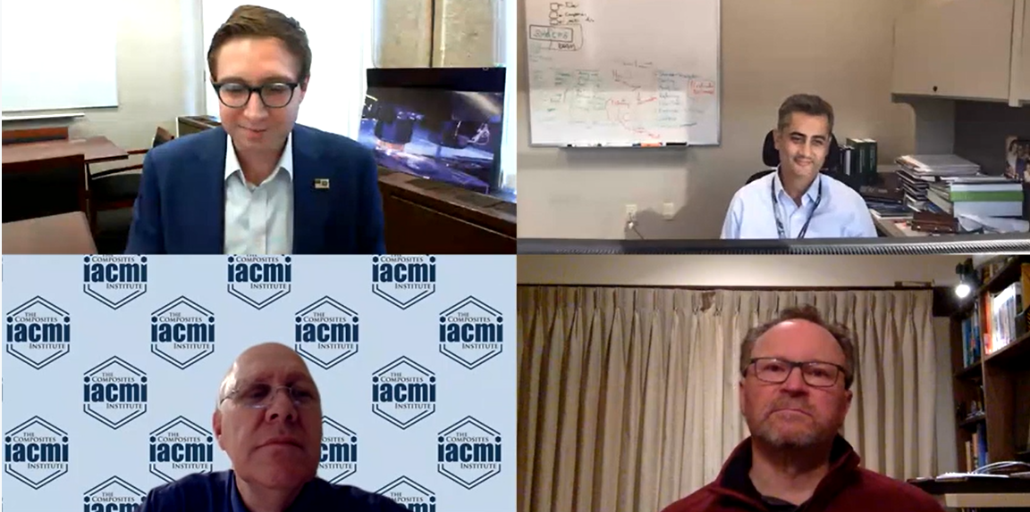
Alex Fitzsimmons (top left) speaking with attendees at the Recycling Working Group meeting about the work the U.S. Department of Energy is doing to support IACMI’s circular economy initiatives.
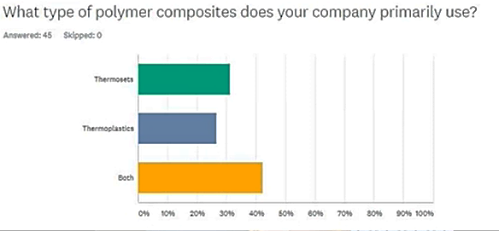
Attendees indicated that there was a mix of material matrices to consider at their host institutions.

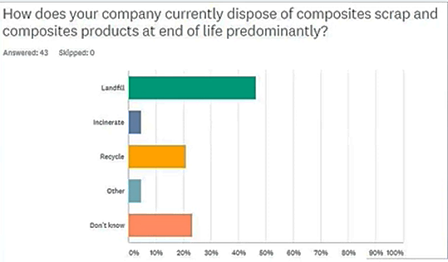
Attendees indicated their waste handling was varied including many using landfill or didn’t know where their end of life material was going. A significant number also indicated they were recycling their end of life materials.

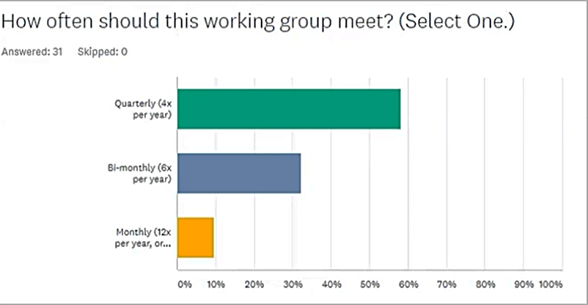
Attendees indicated a quarterly meeting was favored. The next full meeting of the working group will occur the week of February 15 in conjunction with the IACMI Winter Members Meeting.

