IACMI Wind Working Group
Meeting Summary for Inaugural Meeting 10/8/20

The inaugural meeting of the Wind Working Group was held on October 8th during the IACMI fall review. The meeting was held virtually using Microsoft Teams.
84 attendees participated in the session. This turnout demonstrates that there is significant interest in continuing to include wind turbine composites in the scope of IACMI 2.0.
Steve Nolet from TPI Composites and Derek Berry from NREL co-facilitated the session, which lasted one hour. The slide presentation from the meeting has been provided as an attachment to the e-mail with this summary. The link below will take you to a Microsoft Teams recording of the session. You can fast forward to the beginning of the meeting by scrolling to the 11:11 mark.
https://www.dropbox.com/s/w0w1r8tjrt4827w/REMINDER_%20Wind%20Energy%20Working%20Group%20meeting%20-%20IACMI%20Fall%202020%20Members%20Meeting.mp4?dl=0
Derek opened the meeting and provided an introduction of both himself and Steve. Derek next reviewed the agenda for the Wind Working Group meeting.
Dale Brosius provided an overview of the vision for the working group teams that are being formed (slides 3-5 of the Wind Working Group presentation).
Proceeding with the main presentation for the Wind Working Group, Derek began by outlining the draft scope and objectives of the group (slides 7-8). From slide 7 of the presentation, the following would be included in the scope of the Wind Working Group:
- Wind turbine composite structures
- Focus on wind turbine blades
- Other existing and potential composite wind turbine structures
- Potential application to other renewable energy composite structures (e.g., MHK)
- Focus on materials and manufacturing challenges at scale
- Address both technical and economic challenges
- Informed by industry needs / path to commercialization
The objectives of the group, presented on slide 8, include:
- Identify key composite materials and manufacturing challenges in the wind industry that can potentially be addressed through IACMI (Industry, Universities, National Labs) capabilities
- Engage a broader part of the wind industry to provide more insight into current and future challenges
  - OEMs
  - Blade suppliers
  - Material supply chain
  - End users / owner operators
  - Laboratories
  - Certification and standardization bodies
- Develop new guidelines and standards
- Identify research demonstrations at scale to drive a path towards commercialization
Derek provided an overview of the scaling of composites materials and manufacturing for wind (slides 9-21), including wind turbine blade scaling, circular economy/recycling challenges, innovative composite materials, IEA activities for wind turbine blade recycling, and wind industry workforce development.
Derek next described some of the key outcomes of wind materials and manufacturing research during the first five years of IACMI and discussed opportunities to build upon this work (slides 22-33).
Derek finished the presentation by suggesting potential Wind Working Group discussion topics (slide 34).
After Derek finished the initial presentation, Steve continued the Wind Working Group meeting by leading the attendees in an open discussion of potential wind research areas for future IACMI projects. Steve built upon the list from slide 34, expanding the discussion with feedback from the meeting attendees. Steve stressed the need for innovation across research areas to address the vastly increased length/size of blades in the wind industry today and in the future.
During the discussion, many of the attendees participated with questions and comments. The following bullets encapsulate these discussion points:
- Andy Bridge (Janicki Industries) asked what R&D topics might be important to wind turbine OEMs. Steve turned towards other attendees of the working group meeting, such as Alan Walker of GE Renewable Energy, to address this question. Alan noted that there are certainly research areas that OEMs such as GE would consider to be appropriate for collaborative research within IACMI. Steve followed up by noting that all of the topics included on slide 34 are certainly relevant and important to wind turbine OEMs and also for wind blade manufacturers.
- Derek addressed another attendee’s question about onsite manufacturing by describing some of the research completed to date – and focusing on the potential for innovative material and manufacturing technology that could augment blade and tower manufacturing onsite.
- Joe Fox (FX Consulting) commented on some of the recycling challenges for wind turbine blades – noting the potential difficulty on separation of materials while disassembling blades. Steve also asked Ryan Ginder (UTK) to further discuss the future efficacy of recycling for wind turbine blades.
- Shridhar Nath commented on the importance of NDI and health monitoring as wind turbine blades grow in length, including the use of sensors during the manufacturing process that could then also be used for field operation, maintenance, and health monitoring.
- Jeff Sloan (Composites World) inquired about the average retirement age of wind turbine blades today – which Steve estimated to be about 15 years.
- Cliff Eberle (IACMI) commented on the inclusion of composite research for structures other than wind turbine blades, such as other renewable energy areas, etc. – possibly necessitating the need for subgroups.
- Rick Pauer (Polynt Composites) and Alan Walker (GE Renewable Energy) discussed the possibility of 3D printing a polymer concrete version of wind turbine towers.
- Michael Connolly (Huntsman Polyurethanes) commented on the challenges of chemical digestion for wind turbine blades and the impact of transportation costs, with a focus on processing the blade onsite.
- Dave Koester (Vanderbilt University) furthered the discussion on NDI and sensors that could be utilized during blade manufacturing as well as transportation.
- Amolak Badesha (Orbital Composites) noted the opportunity for site-specific optimization with the advent of modular or segmented blades.
- Nagesh Potluri commented on the advances in recycling resin technology for both thermoplastic and thermoset resin systems.

Three surveys were taken during the discussion portion of the meeting.
The first survey asked, “What is your perception of the most challenging problem facing suppliers, manufacturers and end users of wind turbine blades?”. The choices included:
- Fabrication and transportation of 100m+ blades for onshore applications
- Meeting cost/delivery expectations of the industry to continue reduction of LCOE
- Improving O&M Cost and reliability of wind blades
- Decommissioning/disposal/recovery of embodied energy for blades at EOL
- Other (identify)
The results are summarized in the graph below:
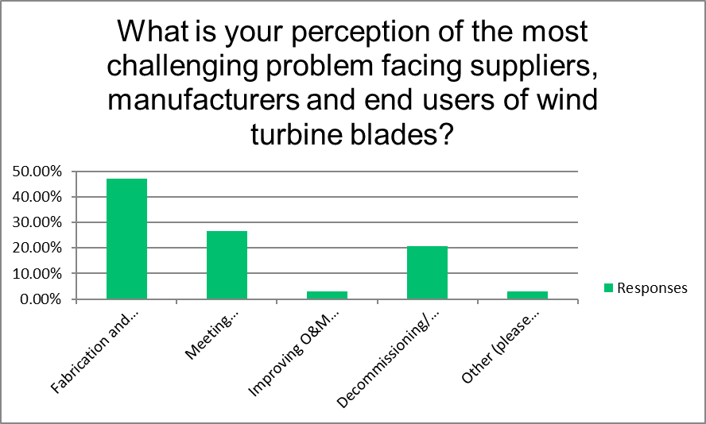

The largest vote-getter was ‘Fabrication and transportation of 100m+ blades for onshore applications’ with almost 50%.

The second survey asked, “What is your vision of for the future of continuous fiber composite recycling? “. The choices included:
- Chemical digestion of matrix system with reclamation of reinforcements
- Recovery of thermal content of matrix/core materials with reclamation of reinforcements
- Repurposing of laminates for other structural applications
- Grind/pulp composite as aggregate for use in cement/asphalt or other infrastructure filler
- Other (identify)
The results are summarized in the graph below:
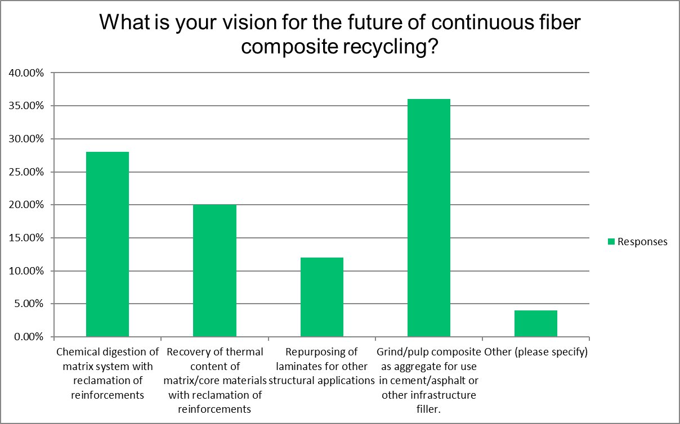
The largest vote-getter was ‘Grind/pulp composite as aggregate for use in cement/asphalt or other infrastructure filler’ with 36%.

The third survey asked about the desired frequency of meetings for the working group. As seen in the graph below, the clear winner was quarterly.
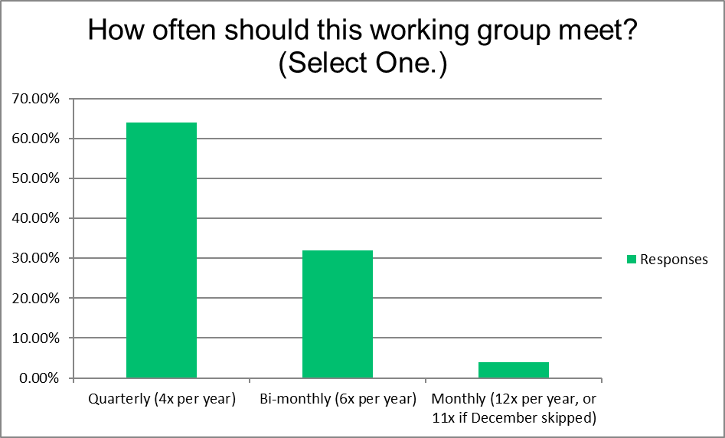

As such, the next meeting will likely be held in early 2021, with the exact date still to be determined.
If you have any questions / comments, please feel free to contact Derek Berry (derek.berry@nrel.gov) or Steve Nolet (snolet@tpicomposites.com).
Next Steps
Please indicate whether you would like to become a member of this Working Group by “Opting-In” within the SurveyMonkey link below.
https://www.surveymonkey.com/r/YWYQ587
By Opting In, you also agree to receive occasional updates and emails about action items and work moving forward. Please provide your feedback as well within the survey as we look to improve our Working Group meetings.

