IACMI Infrastructure Working Group
Meeting Summary for Inaugural Meeting 10/8/20

The inaugural meeting of the Infrastructure Working Group was held on October 8th during the IACMI fall review. The meeting was held virtually using Microsoft Teams.
80 attendees participated in the session. This turnout is considered to be a strong indication that there is significant interest in expanding the scope of IACMI to include Infrastructure in IACMI 2.0.
John Unser from IACMI and Joe Fox from FX Consulting co-facilitated the session, which lasted one hour. The slide presentation from the meeting has been provided as an attachment to the e-mail with this summary. The link below will take you to a Microsoft Teams recording of the session. You can fast forward to the beginning of the meeting by scrolling to the 12:35 mark.
https://www.dropbox.com/s/uj8epbaojpn69sz/REMINDER_%20Infrastructure%20and%20Construction%20Working%20Group%20meeting%20-%20IACMI%20Fall%202020%20Members%20Meeting.mp4?dl=0
Dale Brosius began the meeting with an overview of the vision for the working group teams that are being formed (slides 2-4).
Joe Fox followed with a description of the need and the opportunity using information from the 2017 ASCE Infrastructure Report Card (slides 5-7). The grades for the 16 different segments identified by ASCE are shown below.
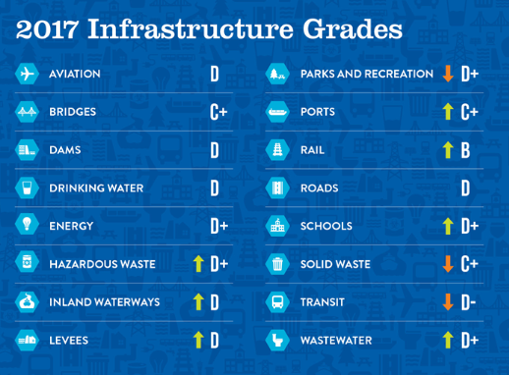
Joe next described the fit between FRP composites and the needs expressed in the Report Card (slides 8 to 22) using slides from a presentation he is scheduled to give to the Central Ohio chapter of ASCE in early November.
John described the fit between Infrastructure and IACMI’s capabilities (slides 23 to 26).
Joe finished the Background section of the meeting with some Voice of the Customer information from ASCE and from the sessions devoted to Infrastructure at the recent CAMX trade show (slides 27 to 31).

Three surveys were taken during the second half of the meeting.
The first survey used the Infrastructure Report Card to identify the market segments that the attendees felt should be in scope for the working group. The results are summarized in the table and graph below. The items specified as “Other” are included in the table. Respondents were asked to select up to five categories.
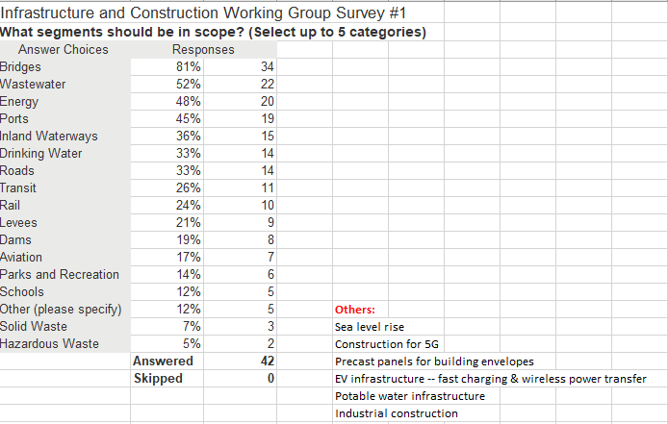
The biggest vote-getter was Bridges which received a score of 80%. The next cluster of Wastewaster, Energy and Ports all came in near 50%, and there was another cluster near 35% that consisted of Inland Waterways, Drinking Water and Roads.
The second survey identified the barriers to adoption that the attendees felt should be addressed by the working group. The results are summarized in the chart below.

The top three vote-getters were Cost-Competitiveness/Life Cycle Cost, Education/Awareness and Lack of Codes & Specifications.
The third survey asked about the desired frequency of meetings for the working group. The clear winner was quarterly.

As such, the next meeting will likely be held soon after the first of the year, exact date TBD.
If you have any questions / comments, please feel free to contact junser@iacmi.org or Joe Fox at foxconsulting147@gmail.com.
Next Steps
Please indicate whether you would like to become a member of this Working Group by “Opting-In” within the SurveyMonkey link below.
https://www.surveymonkey.com/r/DM3PLFQ
By Opting In, you also agree to receive occasional updates and emails about action items and work moving forward. Please provide your feedback as well within the survey as we look to improve our Working Group meetings.

