**HIGH RATE AEROSTRUCTURES FABRICATION IACMI WORKING GROUP**

**Meeting Minutes October 2020**

Meeting Facilitators: Brian Rice (UDRI), Dale Brosius (IACMI)

**IACMI Consortium Working Group General Guidelines**

* **Mission – Focus on addressing technoeconomic barriers to mass adoption of composites in partnership with similarly aligned organizations**
* **Formation**
  + Topic based, ideally formed organically from the membership
  + Members include industry, academic, national laboratory at all levels of consortium
  + Elect chair, meet at least 4x per year, more if desired by group
  + Opportunity to align with external entities (ACMA, ACC, other organizations)
* **Principal Activities**
  + Identify key technical and cost challenges and possible solutions to those
  + Conduct roadmapping as needed specific to topical market or technology focus
  + Inform funding agencies (DOE, DOD, etc.) of priority R&D needs
  + Propose projects for funding – using working group funds or IACMI pool funding
  + Propose mini-conferences or other activities, possibly with outside entities
  + Report activities and successes at IACMI member meetings and other forums, including trade press and conferences

**Group Scope**

* Currently federal and industry partnerships have formed to address broad issues relating to implementation of urban air mobility systems over the next several years.
* Opportunities for high rate manufacturing are projected supporting both commercial single aisle (A320 and 737 series) and urban air mobility aircraft including air-taxi and cargo delivery for short hauls (typically under 100 miles).
* The IACMI consortium is uniquely positioned to foster technology, workforce, and value chain development supporting high rate, low cost aerostructure manufacturing to meet an anticipated rapidly growing need for both defense and commercial needs.

**Group Objectives**

* Facilitate communications regarding issues and opportunities
* Maintain a technology development roadmap
* Communicate manufacturing R&D projects for funding opportunities
* Formulate and conduct directed manufacturing R&D
* Support technology transition through conferences and workshops

Group technoeconomic opportunities and issues were summarized with slides on:

The National Academies Press “Advancing Aerial Mobility: A National Blueprint (2020)

Uber Elevate – Fast Forwarding to a Future of On-Demand Urban Air Transportation

Air Force AFWERX – Agility Prime

NASA – Advanced Air Mobility Supply Chain Working Group

In summary, humanity is entering a new golden age of flight and light weight composite structures are more important than ever to meet future ambitions.

**Poll Results**

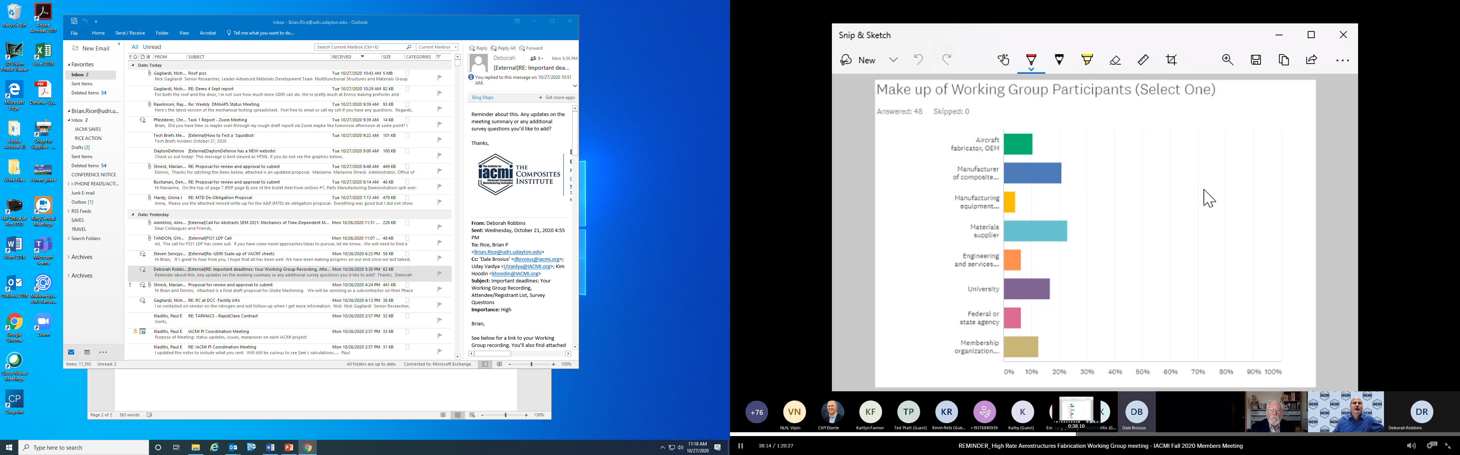

The working group had 191 registrants with 102 attending the meeting and approximately 50 participants responding to the polls. The first poll “Make up of Working Group Participants” shows that all aspects of the value chain and supporting agencies were represented.

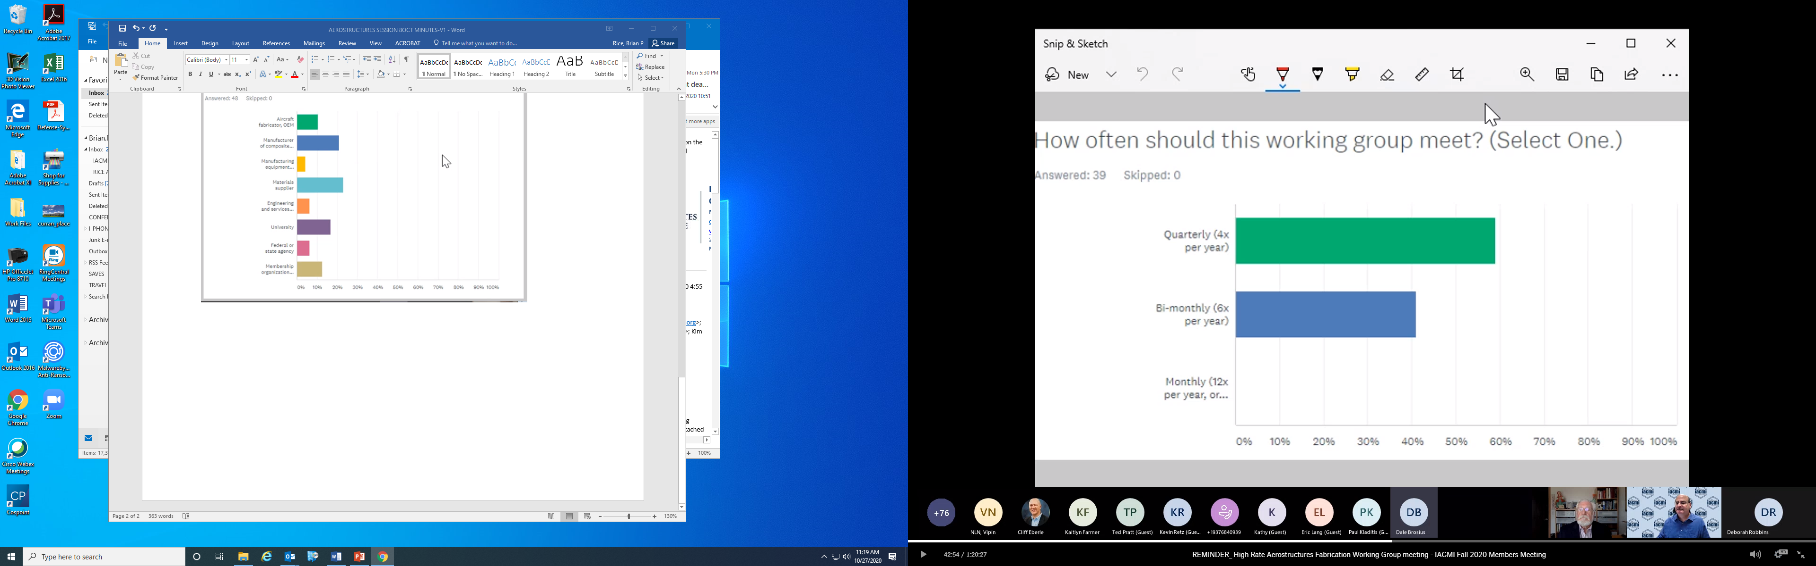

The majority of respondents support a schedule to meet quarterly and add opportunistic joint meetings as appropriate, such as NASA Supply Chain or Vertical Flight Society forums. Potential meeting opportunities for 2021 are presented below.

* + A) Quarterly (4x per year)
    - IACMI virtual member meeting - week of February 15, 2021
    - SAMPE Long Beach – May 24-27, 2021
    - IACMI summer meeting Detroit – week of July 19, 2021
    - CAMX Dallas – October 18-21, 2021

**Poll Topic: Opportunities and Challenges (Select top 3)**

Structure and process certification and material qualification

Developing the value chain

Meeting growth projections

Develop agile, low cost, manufacturing methods

Develop low cost aerospace grade materials

Innovation in composite design and FEA

Education and workforce development

R&D funding opportunities

Opportunity awareness

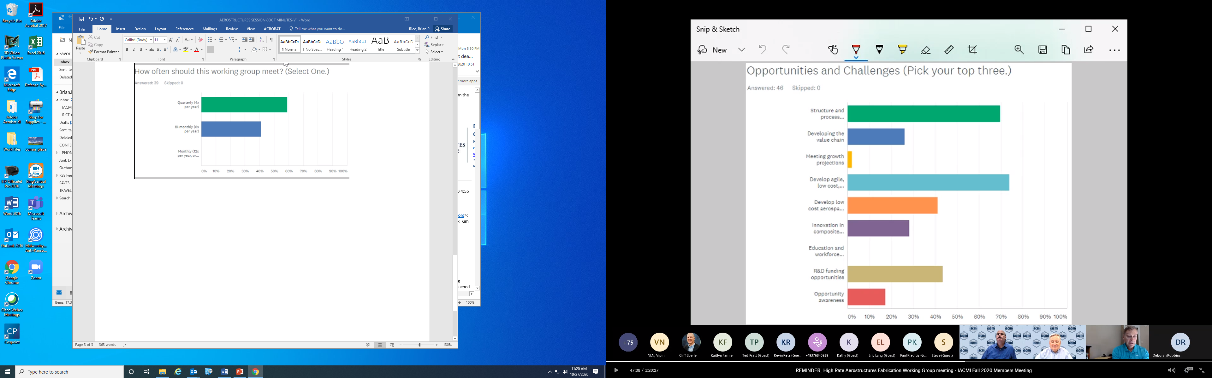

Comments: The top two challenges are “Structure and process certification and material qualification” and “Develop agile, low cost, manufacturing methods.” It is felt that “Meeting growth projections” and “ Workforce development”, will rise to the need when the market presents itself. The market size for UAM will largely be driven by meeting cost goals.

Dan Coughlin (President ACMA) – Reviewed CAMX Urban Air Mobility panel. Discussed synergy with aero, auto, and infrastructure.

Bryan Czapor (Aurora Flight Sciences): UAM has some similarities to Air Force low cost UAV’s. High procurement quantity is only enabled by low cost structures.

Kevin Retz (UDRI): Certification process long and expensive for commercial aviation. UAM new paradigm allows faster innovation for materials and processes.

Jeff Sloan (Composites World): Surprising that “Meeting Growth Projections” was so low in ranking, given that supply chain for UAM does not currently exist. Leverage other composite manufacturing markets.

Craig Neslen (Air Force): Managing programs focused on cost and process reduction for composite structures by leveraging other industries such as automotive. Certification of new materials and processes to reduce cost and time is of interest.

Amanda Simpson (Airbus): Expressed interest in liquid hydrogen tanks for new fuel cell powered air craft.

Vern Benson (Northrup Grumman): Manufacture liquid hydrogen tanks for mission to moon.

**Next Steps**

Please indicate whether you would like to become a member of this Working Group by “Opting-In” within the SurveyMonkey link below.

<https://www.surveymonkey.com/r/Y29TVY8>

By Opting In, you also agree to receive occasional updates and emails about action items and work moving forward.

Please provide your feedback as well within the survey as we look to improve our Working Group meetings.