Creating Virtual Universes to Serve the Composites Industry | Tonya Cole, Dassault Systèmes

IACMI Website Article: https://iacmi.org/2019/07/26/more-than-40-iacmi-the-composites-institute-interns-drive-manufacturing-revolution/

More than 40 IACMI – The Composites Institute Interns Drive Manufacturing Revolution
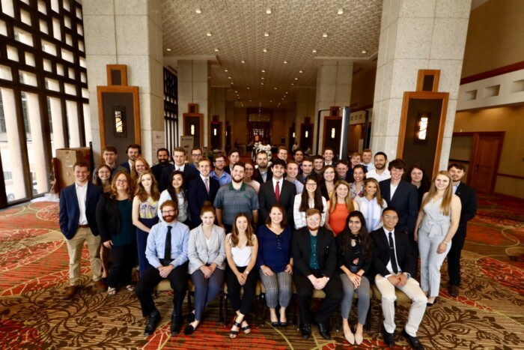
KNOXVILLE, TENN., July 26, 2019 – IACMI – The Composites Institute sponsored 42 students hosted at 17 member and partner locations across the United States. The IACMI Internship Program gives students the opportunity to advance the fourth manufacturing revolution with composites research and innovation, while addressing the growing need to support the advanced manufacturing workforce. IACMI works to close the skills gap to further workforce development at a time where more than half of manufacturing jobs will be left unfilled over the course of the next ten years, due to shifting skillset requirements and a lack of necessary training.
Thought leaders and experts from partner companies, universities, and national laboratories mentored IACMI interns through collaborative research and development projects. Students are integral to advancing composites technical innovations in topic areas such as additive manufacturing (3D printing), robotic systems, and automated integration processes to create solutions supporting manufacturing sustainability and efficiency. Some of the IACMI interns learned from Local Motors, one of IACMI’s small to medium sized member organizations, specializing in low-volume transportation made through additive manufacturing – to prototype autonomous buses with materials testing and systems design for the Olli project. In addition, interns are learned through participating in composite sustainability projects at Vartega, Inc. and the Composites Recycling Technology Center (CRTC) with focus on the environmental impact of recycled composite materials.
The IACMI Internship Program currently has achieved a 100 percent job placement rate for graduated students within six months of graduating from their academic programs. Moreover, the IACMI Intern Class of 2019 is 31 percent female, which is more than double the national average of women in engineering at 15 percent in 2015.
Interns are ending the program both with having made an impact in advancing experimental research and having gained skills to set them up for successful STEM careers. In addition to technical skills, interns honed the soft skills needed to succeed in the workplace, by gaining experience with networking, resume building, and building a positively reflective digital presence. Throughout the internship program, IACMI interns developed the technical and professional skillsets by presenting their summer research to more than 270 composites industry leaders, preparing them to become leading professionals, themselves.
2019 was the fourth year of the IACMI internship program, through the program more than 100 students have been placed at internship locations. IACMI industry members that are involved in the internship program projects in summer 2019 include Ford; Dow Chemical; Volkswagen; DuPont; Vartega Inc.; TPI Composites; Arkema; Structural Composites; 4X Technologies; Local Motors; Additive Engineering Solutions (AES); and Michelman; and regional and academic partners hosts include Vanderbilt University; University of Tennessee, Knoxville; Purdue University; University of Dayton Research Institute; Oak Ridge National Laboratory; National Renewable Energy Laboratory; Michigan State University; and Composites Recycling Technology Center. Previous intern hosts include Dassault Systèmes, Composites Prototyping Center, Arkema, and the Colorado School of Mines. “At IACMI, an essential part of driving the manufacturing revolution is providing diverse opportunities to create the next generation of innovators,” said Joannie Harmon Heath, IACMI Workforce Manager. “Collaboration in the internship program, across industry, academia and government, is critical to ensuring we’re able to support the need for a skilled workforce and prepare underserved populations and students to kickstart their careers.”
“Successfully advancing research and development is dependent on supporting the next generation of talent,” said Andrew Maxey, Vartega Inc. Co-Founder and CEO. “Vartega’s IACMI interns are on a pathway to employment. We’ve kept on two interns over the last year because the internship program gave us direct access to educate and guide top talent to higher level skillsets through significant contributions to Vartega’s sustainable composites solutions.”
The 2019 IACMI summer interns include:
Name | Home University | Host State | IACMI Host Location
Brayden Aller | Vanderbilt University | WA | Composite Recycling Technology Center (CRTC)
Alexandria Banta | Austin Peay State University | TN | Oak Ridge National Laboratory
Kevin Blossfield | University of Dayton | MI | IACMI Scale-Up Research Facility (SURF), managed by MSU
Ryan Clarke | Montana State University | CO | National Renewable Energy Laboratory (NREL)
Zachary Cook | University of Tenn., Knoxville | TN | University of Tenn., Knoxville
Hayley Coughlin | Fordham University | TN | University of Tenn., Knoxville
Caroline Ellis | University of Dayton | OH | University of Dayton Research Institute
Samantha Ford | Chatham University | TN | University of Tenn., Knoxville
Cole Franz | University of Tenn., Knoxville | TN | University of Tenn., Knoxville
Javier Garcia | The University of Texas, Rio Grande Valley | TN | University of Tenn., Knoxville
Dillon Garcia-Wright | University of CO, Boulder | CO | Vartega Inc.
Joseph Gauspohl | University of Tenn., Knoxville | TN | Local Motors
Colby Gilbert | University of Tenn., Knoxville | TN | University of Tenn., Knoxville
Logan Greenlee | Purdue University | OH | Additive Engineering Solutions (AES) / Purdue University
Leo Foster Greer | University of Tenn., Knoxville | CO | Vartega Inc.
Taylor Hamrick | Pellissippi State Community College | TN | 4X Technologies
William Henken | University of Tenn., Knoxville | TN | Local Motors

Liam Herrera | University of Dayton | CO | National Renewable Energy Laboratory (NREL)
Morgan Jenkins | Virginia Polytechnic Institute and State University | TN | Oak Ridge National Laboratory
Colin Kahler | Peninsula College | WA | Composite Recycling Technology Center (CRTC)
Justin LaBelle | Michigan State University (MSU) | TN | University of Tenn., Knoxville
David Lambert | Michigan State University (MSU) | WA | Composite Recycling Technology Center (CRTC)
Bailey Millett | University of Tenn., Knoxville | TN | Michelman / University of Tenn., Knoxville
Kaitlyn Nagel | Colorado School of Mines | CO | Vartega Inc.
Christopher Nash | Vanderbilt University | TN | Vanderbilt University / TPI Composites
Kailey Newcome | Vanderbilt University | DE / TN | DuPont / Vanderbilt University
Casey Nichols | University of North Carolina, Charlotte | CO | National Renewable Energy Laboratory (NREL)
Ryan Ogle | University of Tenn., Knoxville | TN | University of Tenn., Knoxville
Andrew Patchen | University of Tenn., Knoxville | TN | University of Tenn., Knoxville
Tessa Patton | University of Tenn., Knoxville | TN | Michelman / University of Tenn., Knoxville
Sabrinna Rios Romero | Humboldt State University | TN | University of Tenn., Knoxville
Brian Roberts | Stony Brook University | TN | University of Tenn., Knoxville
Russell Alex Rowe | Lamar University | TN | Local Motors
Robert Schickling | University of Alabama, Huntsville | FL | Structural Composites
Susan Schickling | University of Tenn., Knoxville | DE/TN | DuPont / University of Tenn., Knoxville
Isaac Sloan | Colorado State University | TN | University of Tenn., Knoxville
Jennifer Smith | University of Tulsa | MI | IACMI Scale-Up Research Facility (SURF)
Samuel Smith | Purdue University | MI | DuPont
Fiona Sparks | University of Tenn., Knoxville | TN | IACMI Headquarters
Ryan Spencer | University of Tenn., Knoxville | TN | Michelman / University of Tenn., Knoxville
Logan Unser | Tennessee Technological University | CO | National Renewable Energy Laboratory (NREL)
Tony Wente | Michigan State University | DE | DuPont

About IACMI – The Composites Institute: The Institute for Advanced Composites Manufacturing Innovation (IACMI), managed by the Collaborative Composite Solutions Corporation (CCS), is a partnership of industry, universities, national laboratories and federal, state and local governments working together to benefit the nation’s energy and economic security by sharing existing resources and co-investing to accelerate innovative research and development in the advanced composites field. CCS is a not-for-profit organization established by The University of Tennessee Research Foundation. The national Manufacturing USA institute is supported by a $70 million commitment from the U.S. Department of Energy’s Advanced Manufacturing Office and over $180 million committed from IACMI’s partners. Find out more at IACMI.org.

